

ITA0324-Mobile Computing

Name: A. Anusha Reg no:192472083

Slot: C Course Name: Mobile Computing

Experiment 13: Mobile Communication vs Mobile Computing
Aim: To design an infographic comparing mobile communication and mobile computing using Figma.
Procedure:
- Open Figma and create a new design file.
- Create a frame divided into two sections.
- Label the first section as Mobile Communication.
- Label the second section as Mobile Computing.
- Add definitions, technologies, devices, and applications for each section.
- Include examples, similarities, and differences using icons and text.
- Apply suitable colors and arrange the information in a clear comparison layout.

Output:

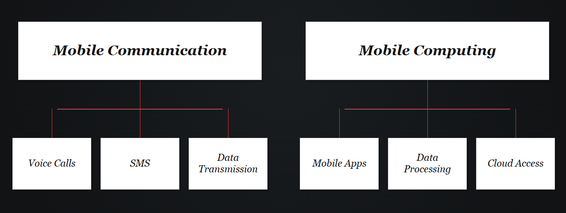
Result: Thus, an infographic comparing mobile communication and mobile computing was designed successfully using Figma.

